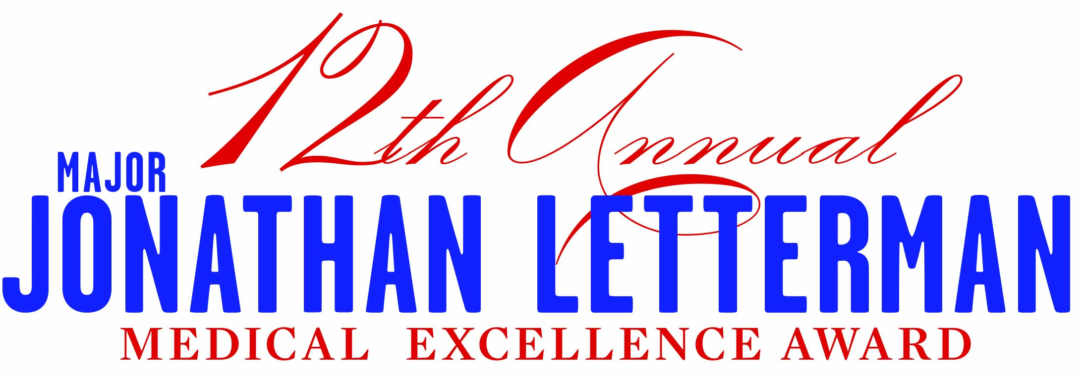
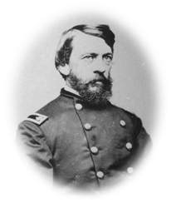
2019 Nomination Information Form

In honor of Dr. Letterman’s visionary work, the National Museum of Civil War Medicine established the annual Letterman Award to recognize an individual or entity that has made an outstanding contribution to improving modern medical processes and patient outcomes.
Nominated by:
Name of person doing the nominating:________________________________________________________________________________________
Position:___________________________________________________Organization:_______________________________________________________
Mailing Address:_________________________________________________________________________________________________________________
Phone:________________________________ Alt Phone:_________________________________
Email:_______________________________________________________________ Date:_______________________________________________________
How were you made aware of Nominee’s work:______________________________________________________________________________
Nominee Information:
Name of Nominee*: _________________________________________________________________________________
*Please include any titles, suffixes, post nominals and military branches that apply to the individual or group

This is an (check one) :
- Individual
- Military Unit
- Military Entity
- Company
- Project Group
- Other (please specify):_________________________________________________________________________

Contact person (nominee):_____________________________________________________________________________________________________
Administrative contact: ________________________________________________________Phone:________________________________________
Address:__________________________________________________________________________________________________________________________
Phone:___________________________________________ Alternate Phone:__________________________________________________________
E-mail:_____________________________________________ Website:________________________________________
All nominations must be submitted by June 30th 2019 to:
National Museum of Civil War Medicine
Rachel Moses
PO Box 470, Frederick, MD 21705
Phone: 301-695-1864 ext. 1006 • E-mail: Rachel.Moses@civilwarmed.org
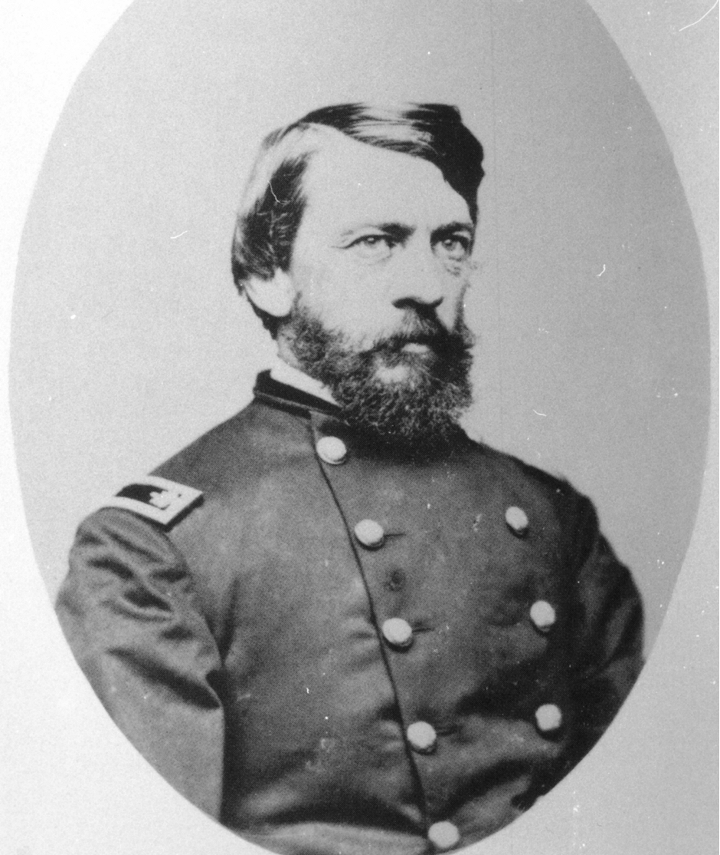

In honor of Major Jonathan Letterman, the Award honors an individual and/or entity that has made an outstanding contribution to improving medical processes and patient outcomes. All award nominees will receive two complimentary tickets to the Letterman Event – additional tickets/tables available to sponsors or individuals for purchase.

Award Recipient will receive:

- Award recipient will be individually recognized at the Event
- Award recipient will receive a memento created especially for the occasion.
- Award recipient programs/achievements will be featured on the NMCWM website
- Award recipient will receive two complimentary tickets to the Letterman Event for 2019
- Award recipient will receive an engraved award.
- Award recipient will receive permanent recognition at the NMCWM.
- Award recipient will be asked to speak in our Letterman Lecture series.

Eligibility & Criteria:

Nominees for the 2019 award may be individuals, military units or entities, companies, organizations or project groups.

Nominees will be:
- Leaders in innovative efforts in civilian emergency or combat casualty care, prosthetic or other medical technology
- Improving outcomes for patients
- Drawing on today’s cutting edge medical technology to develop new ways to assist Armed Forces members or civilians who have suffered severe wounds.

Nomination Information Requested:

Please provide the following information for each nominee. If nominating more than one of the above, please use a separate form for each nomination.

- Describe the type and scope of service before implementation of improved approaches.
- Describe the challenges, issues of the service that necessitated improved approaches
- Describe the innovative approaches employed to improve services.
- Describe how the new approaches have improved patient outcomes.
- Describe any success stories that illustrate the improvement.
- Provide statistics regarding the new approach and its outcomes, if possible.
- Please include any website addresses, documentation, and minimum of four high resolution photographs pertinent to the nomination for use in decision making, promotion and announcement of the award.

Submission Guidelines:

- The first page of the nomination must be the “Nominee Information Form.” Please do not staple pages.
- Nominations must be in a MS Word document, double-spaced on 8 ½ x 11 sheets of paper with a font size of 12 pt.
- Place the name of individual, military unit or entity, company, organization or project group being nominated at the top of each page.
- Please include a “headshot” photo of individual nominees or logo for group.
- Retain one copy of the nomination packet for your records.
- Incomplete Submissions will be returned to the nominator for completion.
- Submissions will be accepted via e-mail to Rachel Moses at Rachel.Moses@civilwarmed.org or they may be mailed to the address below.
- Electronic submissions must be in MS Word format
- Questions regarding the award process can be directed to Rachel Moses, National Museum of Civil War Medicine, 301-695-1864 ext 1006.

Please send Nomination Package to:

National Museum of Civil War Medicine
Attn: Rachel Moses
PO Box 470
Frederick, MD 21705
Rachel. Moses@civilwarmed.org

Nomination Requirements:

- Meets the criteria of the Jonathan Letterman Award for Medical Excellence.
- Nominations must be received by June 30th 2019.
- Nominations are submitted using the Jonathan Letterman Award for Medical Excellence Guidelines.
- Award recipients will be required to submit a short description of their program/approach by June 30 for inclusion in the Jonathan Letterman Award Dinner program. (Videos, or other visual accessories from award recipients, must be submitted prior to August 15.)
- Individual, military unit or entity, company, organization or project group must have a representative that will be able to receive this award at the Jonathan Letterman Award for Medical Excellence Event.
- A point of contact must be established to facilitate communication of information gathering prior to acceptance of nomination.

